Trouble Detail

Project | PIS-BODY | Customer | IMCT
By | Chirayuth S. | Date | 28/03/2011
Problem | - PIS-Server not send instruction data to line PLC,  - After restart the Client and Server program following popups were shown.  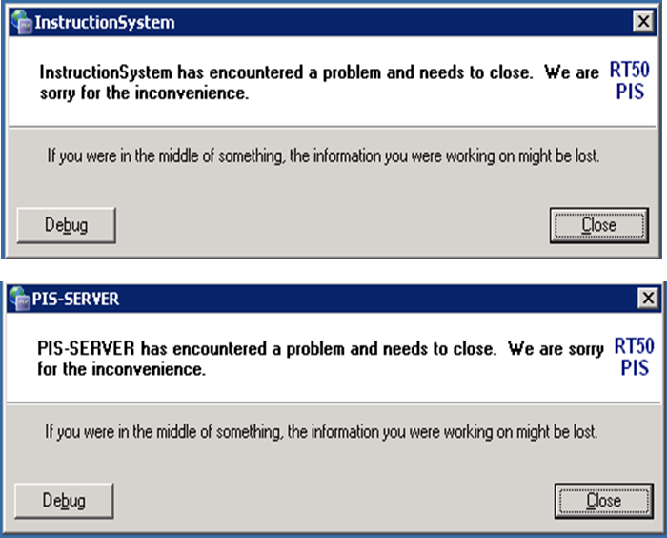
Cause | - Cause of the Problem 1 is when Line 5 PLC’s request status is 04:fault, and the system send 00 to acknowledge the fault, after that PLC should change status code back to 00 then send request 01 again. But from Log file of 23/03/2011 PLC status is always 04:fault, so the system won’t sent instruction data.  - Cannot find the cause yet, since cannot make it occur again.
Relation
Solution | - Check Line PLC or Line equipment about status code.  - Get more information to analyze if the problem occurs again.
Document | SVWD0105420110324_Line05.Log
Remarks

